PERSONAL DATA

|  |  |
| --- | --- |
| **Name:** | Kiselyov Mihail Alekseevich |
| **Date of Birth:** | 19.09.2001 |
| **Location:** | Ukraine |
| **Mobile:** | +380 (98) 586-79-79 |
| **Email address:** | [mkise10@gmail.com](mailto:mkise10@gmail.com) |
| **Social networks:** | [Instagram](https://www.instagram.com/m1sha_lastname/), [Twitter](https://twitter.com/m1sha_lastname) |
| **LinkedIn:** | [linkedin.com/in/simomstam/](http://www.linkedin.com/in/simomstam/) |

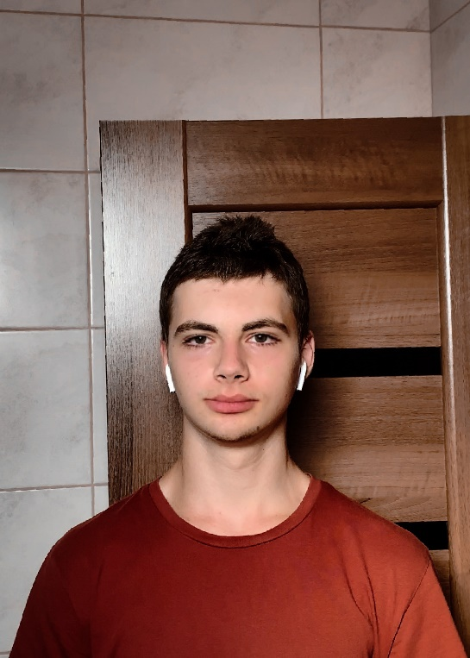

|  |  |
| --- | --- |
| **Target:** | Editor I Category/ Specialist |
| **Desired Position:** | Media content editor |

SUMMARY OF QUALIFICATION

|  |
| --- |
| I am using Adobe Premiere Pro and DaVinci Resolve.  I have more than 4 years of experience with these programs. |

TECHNICAL SKILLS

* Understanding in basic meanings. For example: film components, types of splicing clips, etc.
* I understand many classifications by size (according to Kuleshov or Sokolov)
* Competent in various cutting techniques like Jump cut or Double cutting
* I have an ability to adjust color correction, VHS/ LUT
* I am guided in the axes of interaction, I follow all the rules while editing dialogs
* I creep with advanced types of scene editing. Namely- parallel or cross-cutting

RELEVANT EXPERIENCE

* Scenario writing/ Task for execution
* Assessment of experience and knowledge with a set goal
* Skills and project validation
* Review and evaluation of tasks
* Team management

LANGUAGES

* English- Intermediate
* Russian- Native Speaker
* Ukrainian- Native Speaker

EDUCATION

* 2013 - 2021 / IT STEP Computer Academy / Video/ Photo Editing / Ukraine, Dnipro
* 2019 - 2021 / Classic Private University (CPU)/ Web Design / Ukraine, Dnipro

SEVERAL FACTS ABOUT ME

I prefer a healthy lifestyle. I am free of bad habits.

My hobbies are restoration of a retro car and extreme/ freestyle BMX riding (Bicycle MotoX).

I am engaged in self-development and broadening my horizons thanks to pop-science

From time to time I find strength for interesting projects, like dynamic montages for my [Youtube](https://www.youtube.com/channel/UC8rS1dQbcl-n0BmlktC1WTg) channel.

I can independently find the best way out from a difficult situation in a short time.

I have a pet. This is a cat named Asya.

COURSES, etc.

|  |  |  |  |  |  |  |  |  |  |  |
| --- | --- | --- | --- | --- | --- | --- | --- | --- | --- | --- |
| |  |  | | --- | --- | | **Course name:** | Super Premiere Pro | | **Published:** | VideoSmile | | **Years of education:** | 07/2021 -… / 2021 | | **Certificate License Number:** | - | | **Files:** | - | |